**Customer experience journey map**

Use this framework to better understand customer needs, motivations, and obstacles by illustrating a key scenario or process from start to finish.

When possible, use this map to document and summarize interviews and observations with real people rather than relying on your hunches or assumptions.



Created in partnership with



✴

**Document an existing experience**

Narrow your focus to a specific scenario or process within an existing product or service. In the **Steps** row, document the step-by-step process someone typically experiences, then add detail to each of the other rows.

PROJECT DESIGN PHASE-II

# CUSTOMER JOURNEY MAP

**PNT2022TMI40660 - AI BASED DISCOURSE FOR BANKING INDUSTRY**



[**Share template feedback**](https://muralco.typeform.com/to/CiqaHVat?typeform-source=app.mural.co)



**Need some inspiration?**

|  |  |  |  |  |  |
| --- | --- | --- | --- | --- | --- |
| **SCENARIO**  **Browsing, booking, attending, and rating a local city tour** | **Entice**  How does someone initially become aware of this process? | **Enter**  What do people experience as they begin the process? | **Engage**  In the core moments in the process, what happens? | **Exit**  What do people typically experience  as the process finishes? | **Extend**  What happens after the experience is over? |
| **Steps**  What does the person (or group) typically experience? | **Quick response Avoidance of Manual**  **to Saves Time visiting to BANKS**  **Banking Queries**  **Banking chatbots can take Chatbots help save time by Using chatbots can**  **over the mundane, solving basic customer**  **nonrevenue- queries, so the customer avoid customers to visit**  **generating tasks and support employees have banks each and every**  **support multiple customers at more time to focus on time physically and**  **the same time. complex questions saves their effort.** | **Simple UI**  **text on a screen to the buttons and menus that are used to control a chatbot. The chatbot UI allows users to send messages and tell it what they want it to do.** | **Asking Query Personal banking Quick Customer**  **information comfortable**  **Asking Query Banks are opting for chatbots chatbots into their customer**  **Customers approach to create a personalized service in order to provide Customers can ask their questions**  **chatbots for clarification banking experience. Banking faster and cheaper assistance on their convenient devices at any**  **to their clients who are time and from any location, but**  **on their issues and bots are reducing the waiting becoming increasingly more importantly, they can ask**  **questions. time and other related comfortable with technology. queries as many times as they want.**  **paperwork.** | **Received response**  **Customer will receive clarification on their inquiry as soon as they have finished asking the chatbot.** | **Consumer contentment**  **Once the customer's question is answered, they will be happy. If not, they can speak with a customer service representative to receive more information.** |
| **Interactions**  What interactions do they have at each step along the way?  **People:** Who do they see or talk to?  **Places:** Where are they?  **Things:** What digital touchpoints or physical objects would they use? | **People will interact People will interact**  **with virtual with the dashboard**  **Banking assistant. on the web page.**  **People will use Watson Assistant.** | **Customer will interact with the various options provide in the chatbot from which they choose with which function they want to proceed** | **Customer will interact with the options available in the chatbot from which the customer and chatbot engage to do the required customer task fastly** | **Customer will interact with the feedback form for the session provided by the chatbot.** | **Customer can exit the chatbot or access again if they need the chatbot function again** |
| **Goals & motivations**  At each step, what is a person’s primary goal or motivation? (“Help me...” or “Help me avoid...”) | **Help me to clarify Chatbot should Help me avoid**  **at cover all the irrelevant**  **anytime query information.** | **Help me Help me to have**  **avoid human Help me to avoid more help waiting in line conversations** | **The Bot should be The Bot should be It answers able to answer able to answer loan customers' queries regarding queries requests**  **net banking immediately**  **Help me to clarify The Bot should be The Bot should be**  **my able to guide a able to guide a customer to create a customer to create a**  **doubts bank account bank account** | **It asks whether our It also gives customers**  **doubts are cleared or additional options to**  **if we want to use the contact their bank**  **service again branch.**  **It also properly ends the conversation by way of farewell** | **The chatbot can**  **meet that goal and Customers are no longer It simplifies the internal enhance their waiting weeks, days, organization and experience hours, or even minutes for access and search for**  **an employee to help them. information** |
| **Positive moments**  What steps does a typical person find enjoyable, productive, fun, motivating, delightful, or exciting? | **The chatbot will be They are overjoyed if customers are more enjoyable to they discover this eager to adopt the customer if it's chatbot for simple**  **free to use. banking. new technology** | **Customers are When a consumer sees When a consumer sees excited about using that there is no that there is no seamless customer registration procedure registration procedure**  **service. necessary, they are necessary, they are**  **relieved. relieved.** | **chatbot UI should be easy Customers are Customers enjoy**  **to The customer will be**  **use and understand. It happy to get an instant pleased to have interacting with the bot**  **should also be visually response to any query many options for since they don't become appealing so that users without any delay. their inquiries. annoyed by their constant enjoy interacting with it. questions.** | **As they exit, chatbots As they exit, given that motivate customers to their data isn't stored, it use next-generation makes customers feel at**  **technology. ease.**  **Chatbots make using them more comfortable since they eliminate face-to-face interactions from beginning to end.** | **The customer feels Make the chatbot's delighted and gets behaviour more enlightened after enjoyable so that users finishing using the will return anytime they**  **chatbot like.**  **After their questions were answered, customers no longer felt anxious.** |
| **Negative moments**  What steps does a typical person find frustrating, confusing, angering, costly, or time-consuming? | A consumer will feel Some chatbot  upset if a bank features cost a lot of charges a user to money yet provide utilise a chatbot. good accuracy.  concern about security and privacy breaches. | Some customers People with  may find using disabilities can't  chatbots to be utilise this website confusing. correctly.  The lack of a registration mechanism causes them to be feared. | **If the bot isn't When the chatbot's It takes a lot of When a bot crashes, working correctly, response is inaccurate, time they sometimes have the consumer will be it to look for reliable to**  **angry. will be helpless for the information. restart, which**  **user to seek a solution. aggravates customers.** | **Customers get unsatisfied If the bot ends the when they don't get the chat too soon, the correct answer, even at consumer gets**  **the end of the**  **conversation. unhappy.**  **customers get dissatisfied The chatbot's dialogue with the user wasn't appropriate.** | **Sometimes the chatbot occasionally, offers vague information, chatbots neglect to which causes customers consider client**  **to be confused. insight.**  **Chatbots frequently fail to comprehend natural language, which makes users angry all the time.** |
| **Areas of opportunity**  How might we make each step better? What ideas do we have? What have others suggested? | **Considering Easy**  **better accessibility**  **security to every customers**  **24/7 Availability** | **Easy to Customization**  **access FAQ in user interface**  **Suggesting relevant solution to query** | **Relevant**  **information Seamless Well-trained and increased Communications with FAQs conversation** | **Option to Quicker**  **speak to a help across**  **human the platform agent**  **Conversation Preview** | **End to end Ability to**  **encrypted Learn from**  **conversaion previous conversation**  **Easy accessibility to every customers** |

See a finished version of this template to kickstart your work.

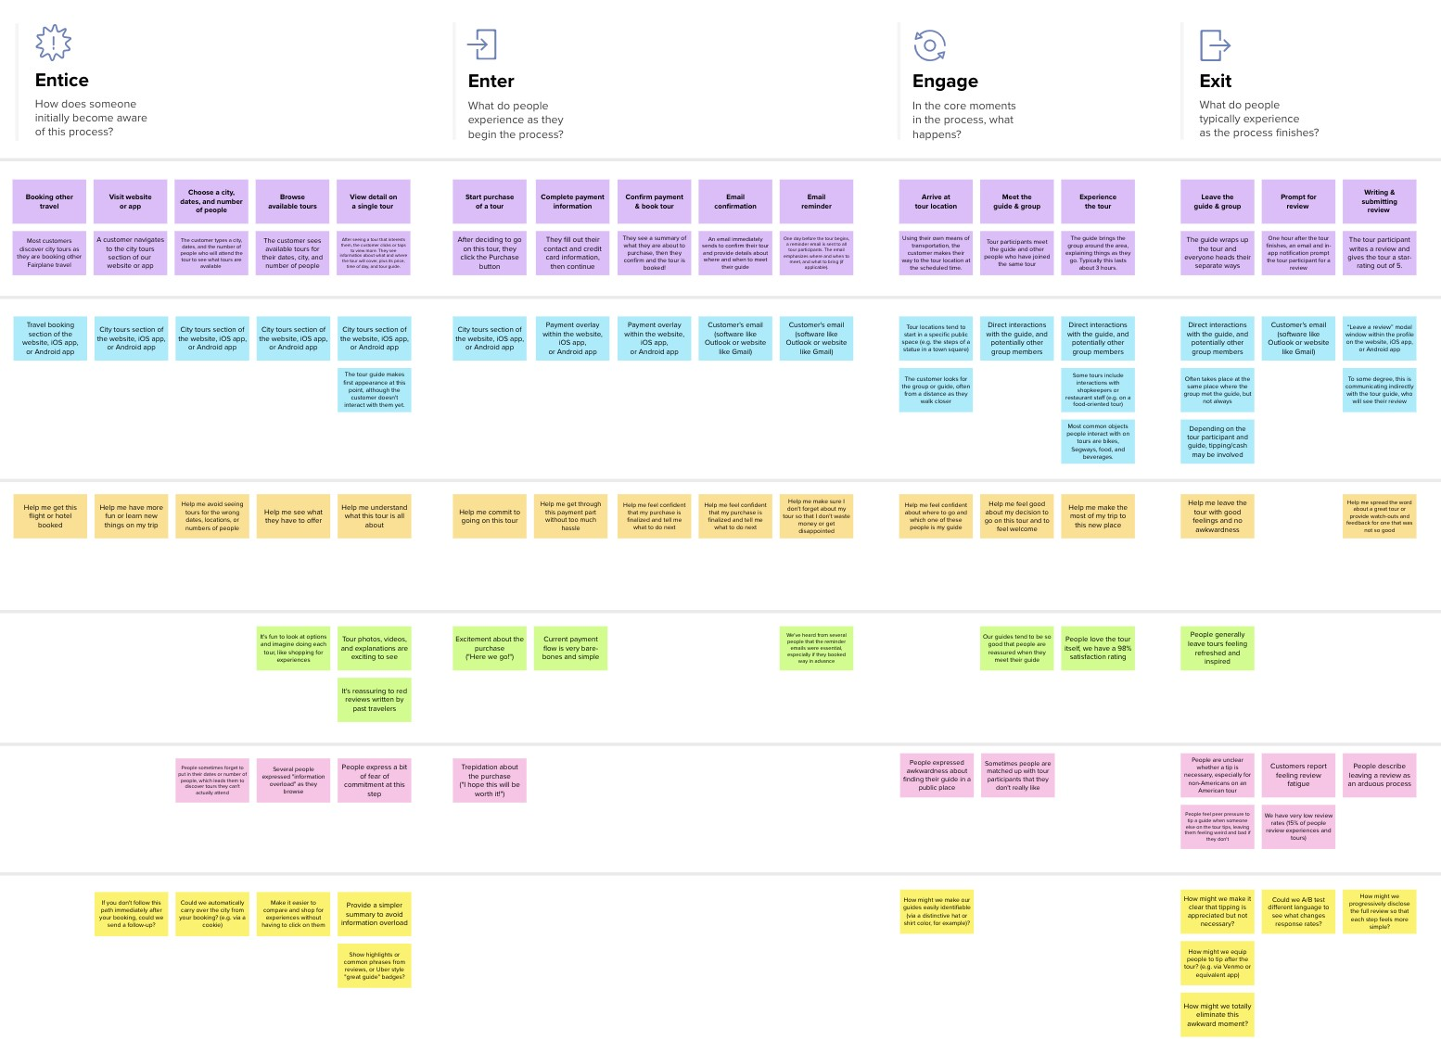

**Template**



[**Open example**](https://app.mural.co/template/f59f644b-b4b4-47b5-9ed6-3a8c71ceb612/896b31fe-5597-40ef-9b06-3811a1a45ace)